Cameron Mathews

August 10, 2021

IT FDN 110 A Su 21

Assignment05

# Modifying an Existing To-Do List Script

### Introduction

The following document outlines the steps taken to modify and update a Python script written by a different author that allows a user to select from a menu of options to input to-do list items and their associated priority level, edit the list, and store the input data into a text file.

### Process

1. Write the script in PyCharm (Figure 1).

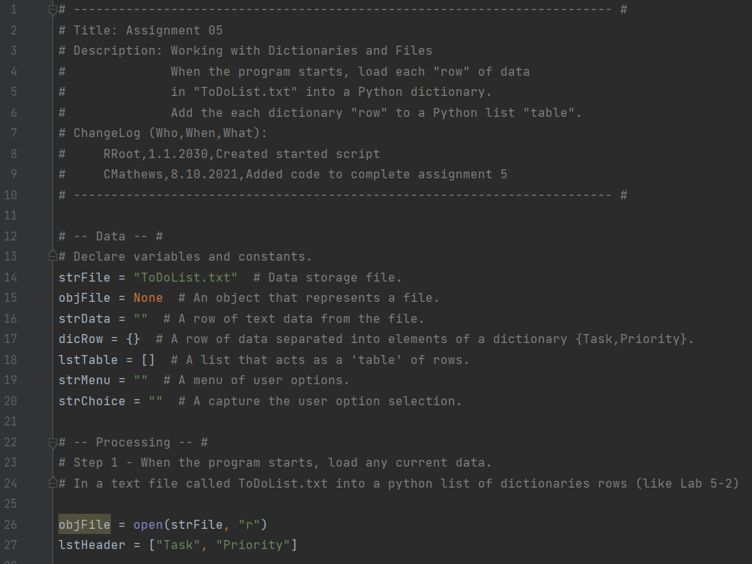

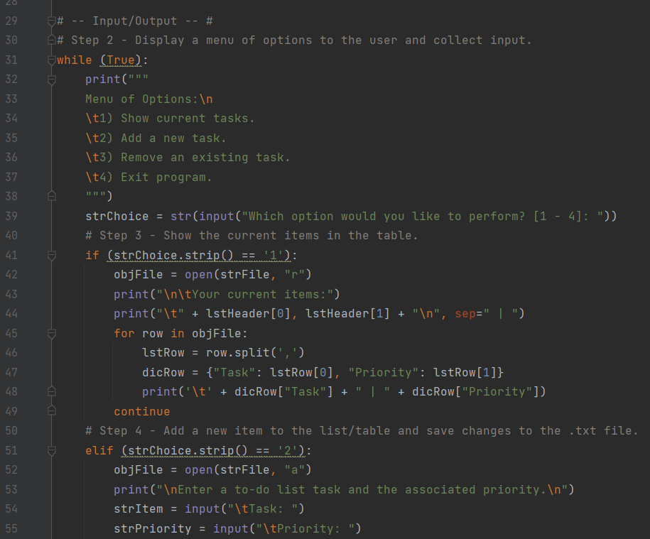

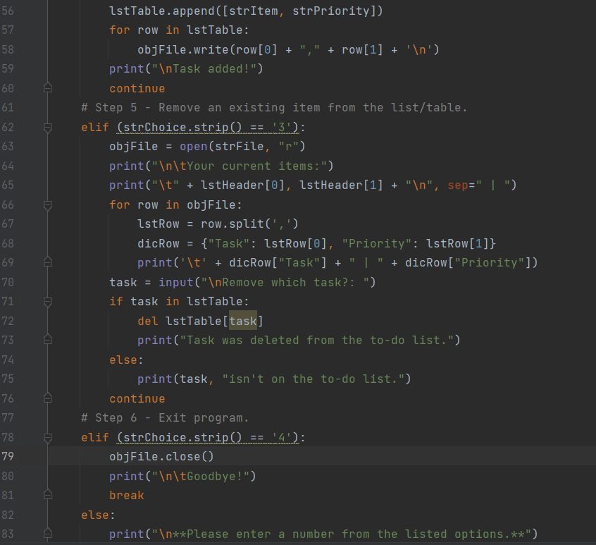

***Figure 1: PyCharm window with detailed script and pseudo-code comments.***

* 1. I’m struggling to understand what parts of the code relating to the table should be out of the while loop vs. in.
  2. The steps to add an item and save it to the .txt file were combined to shorten the code.
  3. The delete script does not work. I ran out of time to troubleshoot.
  4. An exit message was included in the code break to improve user interaction.
  5. An else statement was included to respond to all outlier inputs.

1. Run the script in PyCharm (Figure 2).

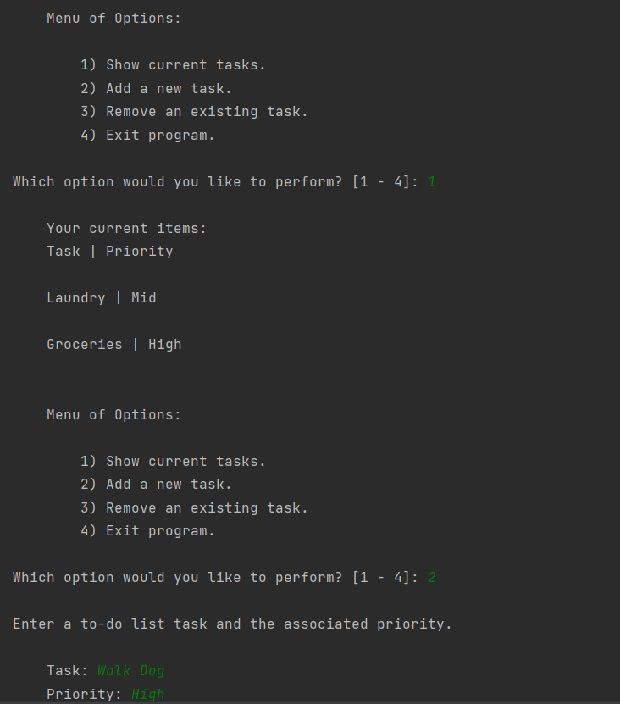

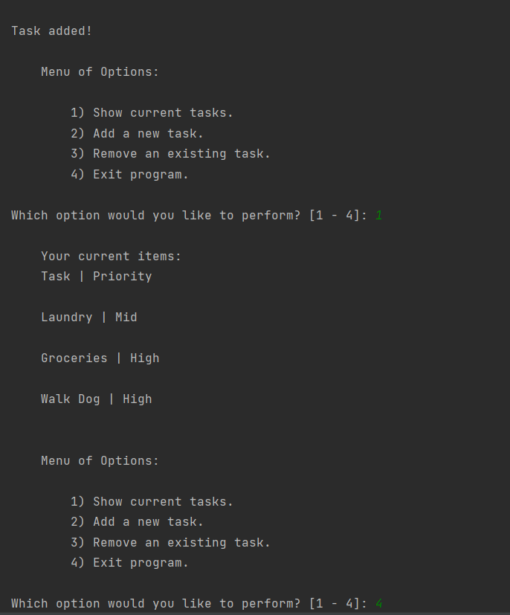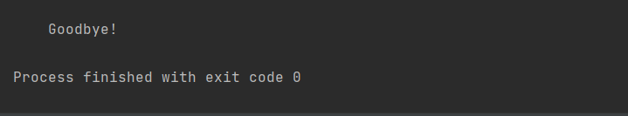

***Figure 2: Example of the script successfully running in the PyCharm window. (Remove task not pictured since code not working).***

1. I would prefer there to be less space in the list but wasn’t clear on how to remove the invisible new line referenced in class.
2. 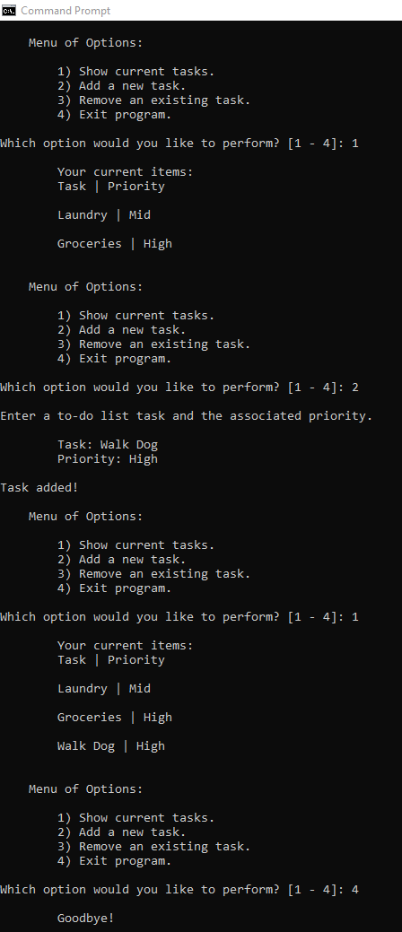Run the script in the Command Prompt window (Figure 3).

***Figure 3: Example of the script successfully running in the Command Prompt window.***

1. Confirm user input is being saved to the defined file location (Figure 4).

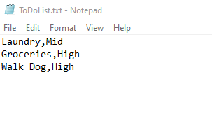

***Figure 4: Image of the text file that appends and saves new user input information.***

### Summary

This document outlined the steps taken to modify and update a Python script written by a different author that allows a user to select from a menu of options to input to-do list items and their associated priority level, edit the list, and store the input data into a text file.